基于Docker容器技术实现—Spark runs on Docker

系统环境：
系统版本：ubuntu14.04 64位系统
系统内核版本：3.13.0-24-generic
Docker版本：Docker version 1.6.2, build 7c8fca2
Spark镜像版本：sequenceiq/spark:1.3.0或者sequenceiq/spark:1.2.0

安装Docker：
执行如下命令：curl -sSL https://get.daocloud.io/docker | sh
查看Docker是否启动运行：ps –ef | grep docker
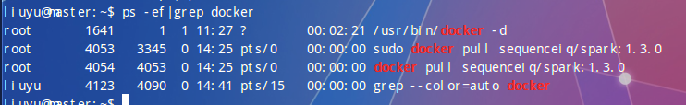
查看Docker版本: docker -v


安装Spark:
查看Docker仓库中的spark镜像：sudo docker search spark
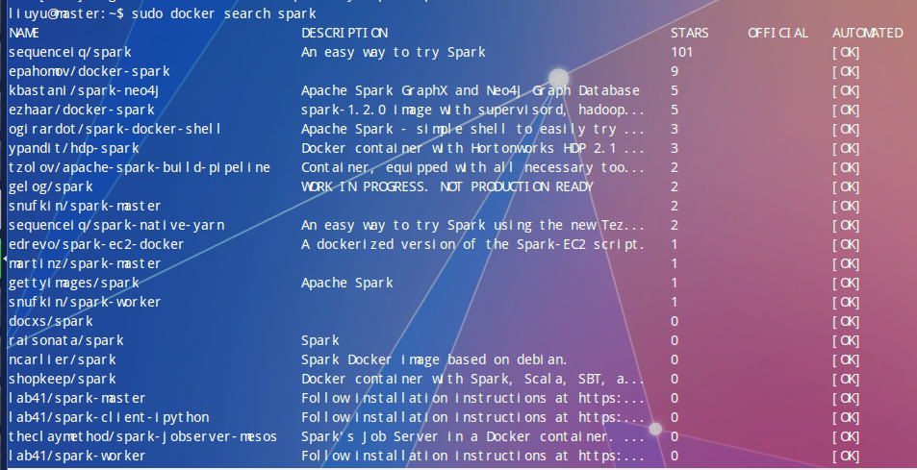
选择STARS高的下载：
下载合适的spark镜像：sudo docker pull sequenceiq/spark:1.3.0
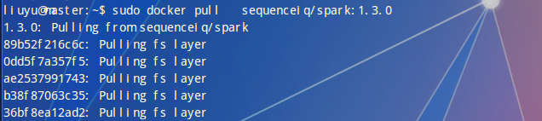
由于网络原因和镜像源的原因，导致下载失败，多次重试依旧失败：
最后使用网友提供的百度云下载链接下载：(sequenceiq/spark:1.2.0版本)
http://pan.baidu.com/s/1dDGREiH
然后可以使用 docker load 从导出的本地文件中再导入到本地镜像库，如下：
sudo docker load --input spark.tar
查看docker 已经存在的docker镜像：
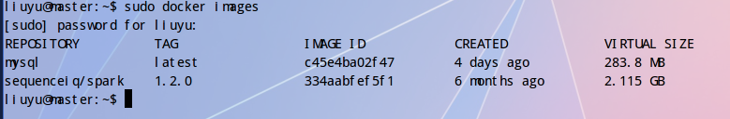
基于Spark镜像启动docker容器：sudo docker run -i -t -h sandbox sequenceiq/spark:1.2.0 /etc/bootstrap.sh -bash
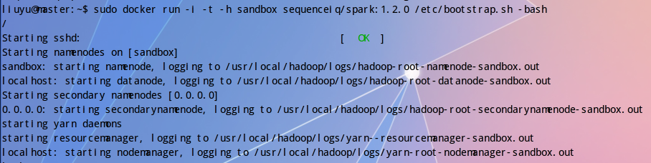

查看运行的docker容器：
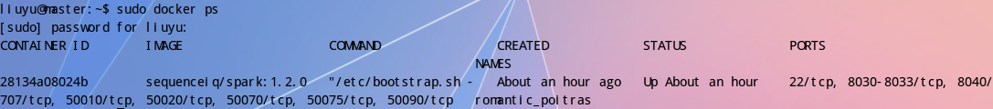

查看docker容器中运行的进程：jps
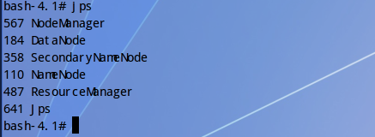

测试Spark:
在容器中切换到spark的安装目录：
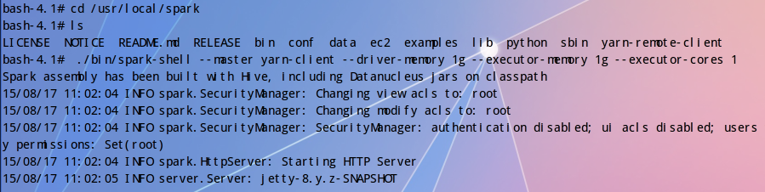
启动spark-shell:
bash-4.1#./bin/spark-shell --master yarn-client --driver-memory 1g --executor-memory 1g --executor-cores 1
Spark assembly has been built with Hive, including Datanucleus jars on classpath
15/08/17 11:02:04 INFO spark.SecurityManager: Changing view acls to: root
15/08/17 11:02:04 INFO spark.SecurityManager: Changing modify acls to: root
15/08/17 11:02:04 INFO spark.SecurityManager: SecurityManager: authentication disabled; ui acls disabled; users with view permissions: Set(root); users with modify permissions: Set(root)
15/08/17 11:02:04 INFO spark.HttpServer: Starting HTTP Server
15/08/17 11:02:05 INFO server.Server: jetty-8.y.z-SNAPSHOT
15/08/17 11:02:05 INFO server.AbstractConnector: Started SocketConnector@0.0.0.0:45032
15/08/17 11:02:05 INFO util.Utils: Successfully started service 'HTTP class server' on port 45032.
Welcome to
____ __
/ __/__ ___ _____/ /__
_\ \/ _ \/ _ `/ __/ '_/
/___/ .__/\_,_/_/ /_/\_\ version 1.2.0
/_/

Using Scala version 2.10.4 (Java HotSpot(TM) 64-Bit Server VM, Java 1.7.0_51)
Type in expressions to have them evaluated.
Type :help for more information.
15/08/17 11:02:21 INFO spark.SecurityManager: Changing view acls to: root
15/08/17 11:02:21 INFO spark.SecurityManager: Changing modify acls to: root
15/08/17 11:02:21 INFO spark.SecurityManager: SecurityManager: authentication disabled; ui acls disabled; users with view permissions: Set(root); users with modify permissions: Set(root)
15/08/17 11:02:23 INFO slf4j.Slf4jLogger: Slf4jLogger started
15/08/17 11:02:23 INFO Remoting: Starting remoting
15/08/17 11:02:24 INFO Remoting: Remoting started; listening on addresses :[akka.tcp://sparkDriver@sandbox:45837]
15/08/17 11:02:24 INFO util.Utils: Successfully started service 'sparkDriver' on port 45837.
15/08/17 11:02:24 INFO spark.SparkEnv: Registering MapOutputTracker
15/08/17 11:02:24 INFO spark.SparkEnv: Registering BlockManagerMaster
15/08/17 11:02:24 INFO storage.DiskBlockManager: Created local directory at /tmp/spark-local-20150817110224-5225
15/08/17 11:02:24 INFO storage.MemoryStore: MemoryStore started with capacity 534.5 MB
15/08/17 11:02:26 WARN util.NativeCodeLoader: Unable to load native-hadoop library for your platform... using builtin-java classes where applicable
15/08/17 11:02:27 INFO spark.HttpFileServer: HTTP File server directory is /tmp/spark-ff037469-c39b-44dc-abda-cefda15b8279
15/08/17 11:02:27 INFO spark.HttpServer: Starting HTTP Server
15/08/17 11:02:27 INFO server.Server: jetty-8.y.z-SNAPSHOT
15/08/17 11:02:27 INFO server.AbstractConnector: Started SocketConnector@0.0.0.0:36707
15/08/17 11:02:27 INFO util.Utils: Successfully started service 'HTTP file server' on port 36707.
15/08/17 11:02:48 INFO server.Server: jetty-8.y.z-SNAPSHOT
15/08/17 11:02:48 INFO server.AbstractConnector: Started SelectChannelConnector@0.0.0.0:4040
15/08/17 11:02:48 INFO util.Utils: Successfully started service 'SparkUI' on port 4040.
15/08/17 11:02:48 INFO ui.SparkUI: Started SparkUI at http://sandbox:4040
15/08/17 11:02:49 INFO client.RMProxy: Connecting to ResourceManager at /0.0.0.0:8032
15/08/17 11:02:51 INFO yarn.Client: Requesting a new application from cluster with 1 NodeManagers
15/08/17 11:02:51 INFO yarn.Client: Verifying our application has not requested more than the maximum memory capability of the cluster (8192 MB per container)
15/08/17 11:02:51 INFO yarn.Client: Will allocate AM container, with 1408 MB memory including 384 MB overhead
15/08/17 11:02:51 INFO yarn.Client: Setting up container launch context for our AM
15/08/17 11:02:51 INFO yarn.Client: Preparing resources for our AM container
15/08/17 11:02:52 WARN yarn.ClientBase: SPARK_JAR detected in the system environment. This variable has been deprecated in favor of the spark.yarn.jar configuration variable.
15/08/17 11:02:52 INFO yarn.Client: Source and destination file systems are the same. Not copying hdfs:/spark/spark-assembly-1.2.0-hadoop2.4.0.jar
15/08/17 11:02:53 INFO yarn.Client: Setting up the launch environment for our AM container
15/08/17 11:02:53 WARN yarn.ClientBase: SPARK_JAR detected in the system environment. This variable has been deprecated in favor of the spark.yarn.jar configuration variable.
15/08/17 11:02:53 INFO spark.SecurityManager: Changing view acls to: root
15/08/17 11:02:53 INFO spark.SecurityManager: Changing modify acls to: root
15/08/17 11:02:53 INFO spark.SecurityManager: SecurityManager: authentication disabled; ui acls disabled; users with view permissions: Set(root); users with modify permissions: Set(root)
15/08/17 11:02:53 INFO yarn.Client: Submitting application 1 to ResourceManager
15/08/17 11:02:53 INFO impl.YarnClientImpl: Submitted application application_1439823464897_0001
15/08/17 11:02:54 INFO yarn.Client: Application report for application_1439823464897_0001 (state: ACCEPTED)
15/08/17 11:02:55 INFO yarn.Client:
client token: N/A
diagnostics: N/A
ApplicationMaster host: N/A
ApplicationMaster RPC port: -1
queue: default
start time: 1439823773704
final status: UNDEFINED
tracking URL: http://sandbox:8088/proxy/application_1439823464897_0001/
user: root
15/08/17 11:02:56 INFO yarn.Client: Application report for application_1439823464897_0001 (state: ACCEPTED)
15/08/17 11:02:57 INFO yarn.Client: Application report for application_1439823464897_0001 (state: ACCEPTED)
15/08/17 11:02:58 INFO yarn.Client: Application report for application_1439823464897_0001 (state: ACCEPTED)
15/08/17 11:02:59 INFO yarn.Client: Application report for application_1439823464897_0001 (state: ACCEPTED)
15/08/17 11:03:00 INFO yarn.Client: Application report for application_1439823464897_0001 (state: ACCEPTED)
15/08/17 11:03:01 INFO yarn.Client: Application report for application_1439823464897_0001 (state: ACCEPTED)
15/08/17 11:03:02 INFO yarn.Client: Application report for application_1439823464897_0001 (state: ACCEPTED)
15/08/17 11:03:03 INFO yarn.Client: Application report for application_1439823464897_0001 (state: ACCEPTED)
15/08/17 11:03:04 INFO yarn.Client: Application report for application_1439823464897_0001 (state: ACCEPTED)
15/08/17 11:03:05 INFO yarn.Client: Application report for application_1439823464897_0001 (state: ACCEPTED)
15/08/17 11:03:06 INFO yarn.Client: Application report for application_1439823464897_0001 (state: ACCEPTED)
15/08/17 11:03:07 INFO yarn.Client: Application report for application_1439823464897_0001 (state: ACCEPTED)
15/08/17 11:03:08 INFO yarn.Client: Application report for application_1439823464897_0001 (state: ACCEPTED)
15/08/17 11:03:09 INFO yarn.Client: Application report for application_1439823464897_0001 (state: ACCEPTED)
15/08/17 11:03:10 INFO yarn.Client: Application report for application_1439823464897_0001 (state: ACCEPTED)
15/08/17 11:03:11 INFO yarn.Client: Application report for application_1439823464897_0001 (state: ACCEPTED)
15/08/17 11:03:12 INFO yarn.Client: Application report for application_1439823464897_0001 (state: ACCEPTED)
15/08/17 11:03:13 INFO yarn.Client: Application report for application_1439823464897_0001 (state: ACCEPTED)
15/08/17 11:03:14 INFO yarn.Client: Application report for application_1439823464897_0001 (state: ACCEPTED)
15/08/17 11:03:15 INFO yarn.Client: Application report for application_1439823464897_0001 (state: ACCEPTED)
15/08/17 11:03:16 INFO yarn.Client: Application report for application_1439823464897_0001 (state: ACCEPTED)
15/08/17 11:03:17 INFO yarn.Client: Application report for application_1439823464897_0001 (state: ACCEPTED)
15/08/17 11:03:18 INFO yarn.Client: Application report for application_1439823464897_0001 (state: ACCEPTED)
15/08/17 11:03:19 INFO yarn.Client: Application report for application_1439823464897_0001 (state: ACCEPTED)
15/08/17 11:03:20 INFO yarn.Client: Application report for application_1439823464897_0001 (state: ACCEPTED)
15/08/17 11:03:21 INFO yarn.Client: Application report for application_1439823464897_0001 (state: ACCEPTED)
15/08/17 11:03:21 INFO cluster.YarnClientSchedulerBackend: ApplicationMaster registered as Actor[akka.tcp://sparkYarnAM@sandbox:45510/user/YarnAM#-305432850]
15/08/17 11:03:21 INFO cluster.YarnClientSchedulerBackend: Add WebUI Filter. org.apache.hadoop.yarn.server.webproxy.amfilter.AmIpFilter, Map(PROXY_HOSTS -> sandbox, PROXY_URI_BASES -> http://sandbox:8088/proxy/application_1439823464897_0001), /proxy/application_1439823464897_0001
15/08/17 11:03:21 INFO ui.JettyUtils: Adding filter: org.apache.hadoop.yarn.server.webproxy.amfilter.AmIpFilter
15/08/17 11:03:22 INFO yarn.Client: Application report for application_1439823464897_0001 (state: RUNNING)
15/08/17 11:03:22 INFO yarn.Client:
client token: N/A
diagnostics: N/A
ApplicationMaster host: sandbox
ApplicationMaster RPC port: 0
queue: default
start time: 1439823773704
final status: UNDEFINED
tracking URL: http://sandbox:8088/proxy/application_1439823464897_0001/
user: root
15/08/17 11:03:22 INFO cluster.YarnClientSchedulerBackend: Application application_1439823464897_0001 has started running.
15/08/17 11:03:23 INFO netty.NettyBlockTransferService: Server created on 41771
15/08/17 11:03:23 INFO storage.BlockManagerMaster: Trying to register BlockManager
15/08/17 11:03:23 INFO storage.BlockManagerMasterActor: Registering block manager sandbox:41771 with 534.5 MB RAM, BlockManagerId(<driver>, sandbox, 41771)
15/08/17 11:03:23 INFO storage.BlockManagerMaster: Registered BlockManager
15/08/17 11:03:24 INFO cluster.YarnClientSchedulerBackend: SchedulerBackend is ready for scheduling beginning after waiting maxRegisteredResourcesWaitingTime: 30000(ms)
15/08/17 11:03:24 INFO repl.SparkILoop: Created spark context..
Spark context available as sc.

scala>
在spark-shell的交互式界面中测试spark：
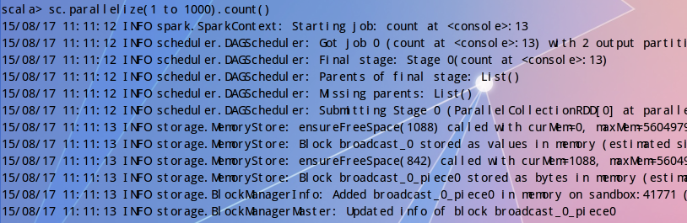
scala> sc.parallelize(1 to 1000).count()
15/08/17 11:11:12 INFO spark.SparkContext: Starting job: count at <console>:13
15/08/17 11:11:12 INFO scheduler.DAGScheduler: Got job 0 (count at <console>:13) with 2 output partitions (allowLocal=false)
15/08/17 11:11:12 INFO scheduler.DAGScheduler: Final stage: Stage 0(count at <console>:13)
15/08/17 11:11:12 INFO scheduler.DAGScheduler: Parents of final stage: List()
15/08/17 11:11:12 INFO scheduler.DAGScheduler: Missing parents: List()
15/08/17 11:11:12 INFO scheduler.DAGScheduler: Submitting Stage 0 (ParallelCollectionRDD[0] at parallelize at <console>:13), which has no missing parents
15/08/17 11:11:13 INFO storage.MemoryStore: ensureFreeSpace(1088) called with curMem=0, maxMem=560497950
15/08/17 11:11:13 INFO storage.MemoryStore: Block broadcast_0 stored as values in memory (estimated size 1088.0 B, free 534.5 MB)
15/08/17 11:11:13 INFO storage.MemoryStore: ensureFreeSpace(842) called with curMem=1088, maxMem=560497950
15/08/17 11:11:13 INFO storage.MemoryStore: Block broadcast_0_piece0 stored as bytes in memory (estimated size 842.0 B, free 534.5 MB)
15/08/17 11:11:13 INFO storage.BlockManagerInfo: Added broadcast_0_piece0 in memory on sandbox:41771 (size: 842.0 B, free: 534.5 MB)
15/08/17 11:11:13 INFO storage.BlockManagerMaster: Updated info of block broadcast_0_piece0
15/08/17 11:11:13 INFO spark.SparkContext: Created broadcast 0 from broadcast at DAGScheduler.scala:838
15/08/17 11:11:13 INFO scheduler.DAGScheduler: Submitting 2 missing tasks from Stage 0 (ParallelCollectionRDD[0] at parallelize at <console>:13)
15/08/17 11:11:13 INFO cluster.YarnClientClusterScheduler: Adding task set 0.0 with 2 tasks
15/08/17 11:11:13 INFO scheduler.TaskSetManager: Starting task 0.0 in stage 0.0 (TID 0, sandbox, PROCESS_LOCAL, 1260 bytes)
15/08/17 11:11:14 INFO scheduler.TaskSetManager: Starting task 1.0 in stage 0.0 (TID 1, sandbox, PROCESS_LOCAL, 1260 bytes)
15/08/17 11:11:15 INFO storage.BlockManagerInfo: Added broadcast_0_piece0 in memory on sandbox:40257 (size: 842.0 B, free: 534.5 MB)
15/08/17 11:11:15 INFO storage.BlockManagerInfo: Added broadcast_0_piece0 in memory on sandbox:44434 (size: 842.0 B, free: 534.5 MB)
15/08/17 11:11:17 INFO scheduler.TaskSetManager: Finished task 1.0 in stage 0.0 (TID 1) in 2924 ms on sandbox (1/2)
15/08/17 11:11:17 INFO scheduler.TaskSetManager: Finished task 0.0 in stage 0.0 (TID 0) in 3131 ms on sandbox (2/2)
15/08/17 11:11:17 INFO scheduler.DAGScheduler: Stage 0 (count at <console>:13) finished in 3.165 s
15/08/17 11:11:17 INFO cluster.YarnClientClusterScheduler: Removed TaskSet 0.0, whose tasks have all completed, from pool
15/08/17 11:11:17 INFO scheduler.DAGScheduler: Job 0 finished: count at <console>:13, took 4.362149 s
res0: Long = 1000

退出spark-shell的交互式模式：
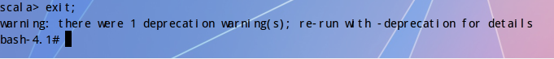
以spark-submit的方式提交作业，测试spark容器：
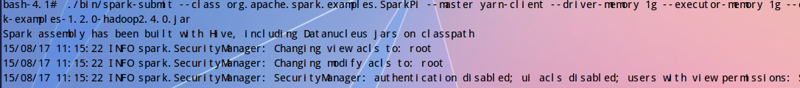
bash-4.1#./bin/spark-submit --class org.apache.spark.examples.SparkPi --master yarn-client --driver-memory 1g --executor-memory 1g --executor-cores 1 ./lib/spark-examples-1.2.0-hadoop2.4.0.jar
Spark assembly has been built with Hive, including Datanucleus jars on classpath
15/08/17 11:15:22 INFO spark.SecurityManager: Changing view acls to: root
15/08/17 11:15:22 INFO spark.SecurityManager: Changing modify acls to: root
15/08/17 11:15:22 INFO spark.SecurityManager: SecurityManager: authentication disabled; ui acls disabled; users with view permissions: Set(root); users with modify permissions: Set(root)
15/08/17 11:15:26 INFO slf4j.Slf4jLogger: Slf4jLogger started
15/08/17 11:15:26 INFO Remoting: Starting remoting
15/08/17 11:15:27 INFO Remoting: Remoting started; listening on addresses :[akka.tcp://sparkDriver@sandbox:55153]
15/08/17 11:15:28 INFO util.Utils: Successfully started service 'sparkDriver' on port 55153.
15/08/17 11:15:28 INFO spark.SparkEnv: Registering MapOutputTracker
15/08/17 11:15:28 INFO spark.SparkEnv: Registering BlockManagerMaster
15/08/17 11:15:28 INFO storage.DiskBlockManager: Created local directory at /tmp/spark-local-20150817111528-d398
15/08/17 11:15:28 INFO storage.MemoryStore: MemoryStore started with capacity 534.5 MB
15/08/17 11:15:31 WARN util.NativeCodeLoader: Unable to load native-hadoop library for your platform... using builtin-java classes where applicable
15/08/17 11:15:33 INFO spark.HttpFileServer: HTTP File server directory is /tmp/spark-50fcfb1c-6342-45cf-936d-a00ea0ceaf6a
15/08/17 11:15:33 INFO spark.HttpServer: Starting HTTP Server
15/08/17 11:15:34 INFO server.Server: jetty-8.y.z-SNAPSHOT
15/08/17 11:15:34 INFO server.AbstractConnector: Started SocketConnector@0.0.0.0:37404
15/08/17 11:15:34 INFO util.Utils: Successfully started service 'HTTP file server' on port 37404.
15/08/17 11:15:55 INFO server.Server: jetty-8.y.z-SNAPSHOT
15/08/17 11:15:55 INFO server.AbstractConnector: Started SelectChannelConnector@0.0.0.0:4040
15/08/17 11:15:55 INFO util.Utils: Successfully started service 'SparkUI' on port 4040.
15/08/17 11:15:55 INFO ui.SparkUI: Started SparkUI at http://sandbox:4040
15/08/17 11:15:58 INFO spark.SparkContext: Added JAR file:/usr/local/spark-1.2.0-bin-hadoop2.4/./lib/spark-examples-1.2.0-hadoop2.4.0.jar at http://172.17.0.1:37404/jars/spark-examples-1.2.0-hadoop2.4.0.jar with timestamp 1439824558311
15/08/17 11:15:58 INFO client.RMProxy: Connecting to ResourceManager at /0.0.0.0:8032
15/08/17 11:16:00 INFO yarn.Client: Requesting a new application from cluster with 1 NodeManagers
15/08/17 11:16:00 INFO yarn.Client: Verifying our application has not requested more than the maximum memory capability of the cluster (8192 MB per container)
15/08/17 11:16:00 INFO yarn.Client: Will allocate AM container, with 1408 MB memory including 384 MB overhead
15/08/17 11:16:00 INFO yarn.Client: Setting up container launch context for our AM
15/08/17 11:16:00 INFO yarn.Client: Preparing resources for our AM container
15/08/17 11:16:03 WARN yarn.ClientBase: SPARK_JAR detected in the system environment. This variable has been deprecated in favor of the spark.yarn.jar configuration variable.
15/08/17 11:16:03 INFO yarn.Client: Source and destination file systems are the same. Not copying hdfs:/spark/spark-assembly-1.2.0-hadoop2.4.0.jar
15/08/17 11:16:04 INFO yarn.Client: Setting up the launch environment for our AM container
15/08/17 11:16:04 WARN yarn.ClientBase: SPARK_JAR detected in the system environment. This variable has been deprecated in favor of the spark.yarn.jar configuration variable.
15/08/17 11:16:04 INFO spark.SecurityManager: Changing view acls to: root
15/08/17 11:16:04 INFO spark.SecurityManager: Changing modify acls to: root
15/08/17 11:16:04 INFO spark.SecurityManager: SecurityManager: authentication disabled; ui acls disabled; users with view permissions: Set(root); users with modify permissions: Set(root)
15/08/17 11:16:04 INFO yarn.Client: Submitting application 2 to ResourceManager
15/08/17 11:16:05 INFO impl.YarnClientImpl: Submitted application application_1439823464897_0002
15/08/17 11:16:06 INFO yarn.Client: Application report for application_1439823464897_0002 (state: ACCEPTED)
15/08/17 11:16:06 INFO yarn.Client:
client token: N/A
diagnostics: N/A
ApplicationMaster host: N/A
ApplicationMaster RPC port: -1
queue: default
start time: 1439824564975
final status: UNDEFINED
tracking URL: http://sandbox:8088/proxy/application_1439823464897_0002/
user: root
15/08/17 11:16:07 INFO yarn.Client: Application report for application_1439823464897_0002 (state: ACCEPTED)
15/08/17 11:16:08 INFO yarn.Client: Application report for application_1439823464897_0002 (state: ACCEPTED)
15/08/17 11:16:09 INFO yarn.Client: Application report for application_1439823464897_0002 (state: ACCEPTED)
15/08/17 11:16:10 INFO yarn.Client: Application report for application_1439823464897_0002 (state: ACCEPTED)
15/08/17 11:16:11 INFO yarn.Client: Application report for application_1439823464897_0002 (state: ACCEPTED)
15/08/17 11:16:12 INFO yarn.Client: Application report for application_1439823464897_0002 (state: ACCEPTED)
15/08/17 11:16:13 INFO yarn.Client: Application report for application_1439823464897_0002 (state: ACCEPTED)
15/08/17 11:16:14 INFO yarn.Client: Application report for application_1439823464897_0002 (state: ACCEPTED)
15/08/17 11:16:15 INFO yarn.Client: Application report for application_1439823464897_0002 (state: ACCEPTED)
15/08/17 11:16:16 INFO yarn.Client: Application report for application_1439823464897_0002 (state: ACCEPTED)
15/08/17 11:16:17 INFO yarn.Client: Application report for application_1439823464897_0002 (state: ACCEPTED)
15/08/17 11:16:18 INFO yarn.Client: Application report for application_1439823464897_0002 (state: ACCEPTED)
15/08/17 11:16:19 INFO yarn.Client: Application report for application_1439823464897_0002 (state: ACCEPTED)
15/08/17 11:16:20 INFO yarn.Client: Application report for application_1439823464897_0002 (state: ACCEPTED)
15/08/17 11:16:21 INFO yarn.Client: Application report for application_1439823464897_0002 (state: ACCEPTED)
15/08/17 11:16:22 INFO yarn.Client: Application report for application_1439823464897_0002 (state: ACCEPTED)
15/08/17 11:16:23 INFO yarn.Client: Application report for application_1439823464897_0002 (state: ACCEPTED)
15/08/17 11:16:24 INFO yarn.Client: Application report for application_1439823464897_0002 (state: ACCEPTED)
15/08/17 11:16:25 INFO yarn.Client: Application report for application_1439823464897_0002 (state: ACCEPTED)
15/08/17 11:16:26 INFO yarn.Client: Application report for application_1439823464897_0002 (state: ACCEPTED)
15/08/17 11:16:27 INFO yarn.Client: Application report for application_1439823464897_0002 (state: ACCEPTED)
15/08/17 11:16:28 INFO yarn.Client: Application report for application_1439823464897_0002 (state: ACCEPTED)
15/08/17 11:16:29 INFO yarn.Client: Application report for application_1439823464897_0002 (state: ACCEPTED)
15/08/17 11:16:30 INFO cluster.YarnClientSchedulerBackend: ApplicationMaster registered as Actor[akka.tcp://sparkYarnAM@sandbox:53880/user/YarnAM#-1619648980]
15/08/17 11:16:30 INFO cluster.YarnClientSchedulerBackend: Add WebUI Filter. org.apache.hadoop.yarn.server.webproxy.amfilter.AmIpFilter, Map(PROXY_HOSTS -> sandbox, PROXY_URI_BASES -> http://sandbox:8088/proxy/application_1439823464897_0002), /proxy/application_1439823464897_0002
15/08/17 11:16:30 INFO ui.JettyUtils: Adding filter: org.apache.hadoop.yarn.server.webproxy.amfilter.AmIpFilter
15/08/17 11:16:30 INFO yarn.Client: Application report for application_1439823464897_0002 (state: RUNNING)
15/08/17 11:16:30 INFO yarn.Client:
client token: N/A
diagnostics: N/A
ApplicationMaster host: sandbox
ApplicationMaster RPC port: 0
queue: default
start time: 1439824564975
final status: UNDEFINED
tracking URL: http://sandbox:8088/proxy/application_1439823464897_0002/
user: root
15/08/17 11:16:30 INFO cluster.YarnClientSchedulerBackend: Application application_1439823464897_0002 has started running.
15/08/17 11:16:32 INFO netty.NettyBlockTransferService: Server created on 60763
15/08/17 11:16:32 INFO storage.BlockManagerMaster: Trying to register BlockManager
15/08/17 11:16:32 INFO storage.BlockManagerMasterActor: Registering block manager sandbox:60763 with 534.5 MB RAM, BlockManagerId(<driver>, sandbox, 60763)
15/08/17 11:16:32 INFO storage.BlockManagerMaster: Registered BlockManager
15/08/17 11:16:32 INFO cluster.YarnClientSchedulerBackend: SchedulerBackend is ready for scheduling beginning after waiting maxRegisteredResourcesWaitingTime: 30000(ms)
15/08/17 11:16:33 INFO spark.SparkContext: Starting job: reduce at SparkPi.scala:35
15/08/17 11:16:33 INFO scheduler.DAGScheduler: Got job 0 (reduce at SparkPi.scala:35) with 2 output partitions (allowLocal=false)
15/08/17 11:16:33 INFO scheduler.DAGScheduler: Final stage: Stage 0(reduce at SparkPi.scala:35)
15/08/17 11:16:33 INFO scheduler.DAGScheduler: Parents of final stage: List()
15/08/17 11:16:33 INFO scheduler.DAGScheduler: Missing parents: List()
15/08/17 11:16:33 INFO scheduler.DAGScheduler: Submitting Stage 0 (MappedRDD[1] at map at SparkPi.scala:31), which has no missing parents
15/08/17 11:16:34 INFO storage.MemoryStore: ensureFreeSpace(1728) called with curMem=0, maxMem=560497950
15/08/17 11:16:34 INFO storage.MemoryStore: Block broadcast_0 stored as values in memory (estimated size 1728.0 B, free 534.5 MB)
15/08/17 11:16:34 INFO storage.MemoryStore: ensureFreeSpace(1235) called with curMem=1728, maxMem=560497950
15/08/17 11:16:34 INFO storage.MemoryStore: Block broadcast_0_piece0 stored as bytes in memory (estimated size 1235.0 B, free 534.5 MB)
15/08/17 11:16:34 INFO storage.BlockManagerInfo: Added broadcast_0_piece0 in memory on sandbox:60763 (size: 1235.0 B, free: 534.5 MB)
15/08/17 11:16:34 INFO storage.BlockManagerMaster: Updated info of block broadcast_0_piece0
15/08/17 11:16:34 INFO spark.SparkContext: Created broadcast 0 from broadcast at DAGScheduler.scala:838
15/08/17 11:16:35 INFO scheduler.DAGScheduler: Submitting 2 missing tasks from Stage 0 (MappedRDD[1] at map at SparkPi.scala:31)
15/08/17 11:16:35 INFO cluster.YarnClientClusterScheduler: Adding task set 0.0 with 2 tasks
15/08/17 11:16:50 WARN cluster.YarnClientClusterScheduler: Initial job has not accepted any resources; check your cluster UI to ensure that workers are registered and have sufficient memory
15/08/17 11:17:05 WARN cluster.YarnClientClusterScheduler: Initial job has not accepted any resources; check your cluster UI to ensure that workers are registered and have sufficient memory
15/08/17 11:17:14 INFO cluster.YarnClientSchedulerBackend: Registered executor: Actor[akka.tcp://sparkExecutor@sandbox:38635/user/Executor#-1972174476] with ID 2
15/08/17 11:17:15 INFO util.RackResolver: Resolved sandbox to /default-rack
15/08/17 11:17:15 INFO scheduler.TaskSetManager: Starting task 0.0 in stage 0.0 (TID 0, sandbox, PROCESS_LOCAL, 1335 bytes)
15/08/17 11:17:15 INFO cluster.YarnClientSchedulerBackend: Registered executor: Actor[akka.tcp://sparkExecutor@sandbox:49011/user/Executor#-549185991] with ID 1
15/08/17 11:17:15 INFO scheduler.TaskSetManager: Starting task 1.0 in stage 0.0 (TID 1, sandbox, PROCESS_LOCAL, 1335 bytes)
15/08/17 11:17:22 INFO storage.BlockManagerMasterActor: Registering block manager sandbox:41010 with 534.5 MB RAM, BlockManagerId(2, sandbox, 41010)
15/08/17 11:17:23 INFO storage.BlockManagerMasterActor: Registering block manager sandbox:42339 with 534.5 MB RAM, BlockManagerId(1, sandbox, 42339)
15/08/17 11:17:34 INFO storage.BlockManagerInfo: Added broadcast_0_piece0 in memory on sandbox:42339 (size: 1235.0 B, free: 534.5 MB)
15/08/17 11:17:34 INFO storage.BlockManagerInfo: Added broadcast_0_piece0 in memory on sandbox:41010 (size: 1235.0 B, free: 534.5 MB)
15/08/17 11:17:39 INFO scheduler.TaskSetManager: Finished task 1.0 in stage 0.0 (TID 1) in 23719 ms on sandbox (1/2)
15/08/17 11:17:39 INFO scheduler.DAGScheduler: Stage 0 (reduce at SparkPi.scala:35) finished in 64.138 s
15/08/17 11:17:39 INFO scheduler.TaskSetManager: Finished task 0.0 in stage 0.0 (TID 0) in 24211 ms on sandbox (2/2)
15/08/17 11:17:39 INFO cluster.YarnClientClusterScheduler: Removed TaskSet 0.0, whose tasks have all completed, from pool
15/08/17 11:17:39 INFO scheduler.DAGScheduler: Job 0 finished: reduce at SparkPi.scala:35, took 66.046480 s
Pi is roughly 3.1482
15/08/17 11:17:39 INFO handler.ContextHandler: stopped o.e.j.s.ServletContextHandler{/stages/stage/kill,null}
15/08/17 11:17:39 INFO handler.ContextHandler: stopped o.e.j.s.ServletContextHandler{/,null}
15/08/17 11:17:39 INFO handler.ContextHandler: stopped o.e.j.s.ServletContextHandler{/static,null}
15/08/17 11:17:39 INFO handler.ContextHandler: stopped o.e.j.s.ServletContextHandler{/executors/threadDump/json,null}
15/08/17 11:17:39 INFO handler.ContextHandler: stopped o.e.j.s.ServletContextHandler{/executors/threadDump,null}
15/08/17 11:17:39 INFO handler.ContextHandler: stopped o.e.j.s.ServletContextHandler{/executors/json,null}
15/08/17 11:17:39 INFO handler.ContextHandler: stopped o.e.j.s.ServletContextHandler{/executors,null}
15/08/17 11:17:39 INFO handler.ContextHandler: stopped o.e.j.s.ServletContextHandler{/environment/json,null}
15/08/17 11:17:39 INFO handler.ContextHandler: stopped o.e.j.s.ServletContextHandler{/environment,null}
15/08/17 11:17:39 INFO handler.ContextHandler: stopped o.e.j.s.ServletContextHandler{/storage/rdd/json,null}
15/08/17 11:17:39 INFO handler.ContextHandler: stopped o.e.j.s.ServletContextHandler{/storage/rdd,null}
15/08/17 11:17:39 INFO handler.ContextHandler: stopped o.e.j.s.ServletContextHandler{/storage/json,null}
15/08/17 11:17:39 INFO handler.ContextHandler: stopped o.e.j.s.ServletContextHandler{/storage,null}
15/08/17 11:17:39 INFO handler.ContextHandler: stopped o.e.j.s.ServletContextHandler{/stages/pool/json,null}
15/08/17 11:17:39 INFO handler.ContextHandler: stopped o.e.j.s.ServletContextHandler{/stages/pool,null}
15/08/17 11:17:39 INFO handler.ContextHandler: stopped o.e.j.s.ServletContextHandler{/stages/stage/json,null}
15/08/17 11:17:39 INFO handler.ContextHandler: stopped o.e.j.s.ServletContextHandler{/stages/stage,null}
15/08/17 11:17:39 INFO handler.ContextHandler: stopped o.e.j.s.ServletContextHandler{/stages/json,null}
15/08/17 11:17:39 INFO handler.ContextHandler: stopped o.e.j.s.ServletContextHandler{/stages,null}
15/08/17 11:17:39 INFO handler.ContextHandler: stopped o.e.j.s.ServletContextHandler{/jobs/job/json,null}
15/08/17 11:17:39 INFO handler.ContextHandler: stopped o.e.j.s.ServletContextHandler{/jobs/job,null}
15/08/17 11:17:39 INFO handler.ContextHandler: stopped o.e.j.s.ServletContextHandler{/jobs/json,null}
15/08/17 11:17:39 INFO handler.ContextHandler: stopped o.e.j.s.ServletContextHandler{/jobs,null}
15/08/17 11:17:39 INFO ui.SparkUI: Stopped Spark web UI at http://sandbox:4040
15/08/17 11:17:39 INFO scheduler.DAGScheduler: Stopping DAGScheduler
15/08/17 11:17:39 INFO cluster.YarnClientSchedulerBackend: Shutting down all executors
15/08/17 11:17:39 INFO cluster.YarnClientSchedulerBackend: Asking each executor to shut down
15/08/17 11:17:39 INFO cluster.YarnClientSchedulerBackend: Stopped
15/08/17 11:17:40 INFO spark.MapOutputTrackerMasterActor: MapOutputTrackerActor stopped!
15/08/17 11:17:41 INFO storage.MemoryStore: MemoryStore cleared
15/08/17 11:17:41 INFO storage.BlockManager: BlockManager stopped
15/08/17 11:17:41 INFO storage.BlockManagerMaster: BlockManagerMaster stopped
15/08/17 11:17:41 INFO remote.RemoteActorRefProvider$RemotingTerminator: Shutting down remote daemon.
15/08/17 11:17:41 INFO remote.RemoteActorRefProvider$RemotingTerminator: Remote daemon shut down; proceeding with flushing remote transports.
15/08/17 11:17:41 INFO spark.SparkContext: Successfully stopped SparkContext
bash-4.1#
查看提交作业的运行情况：
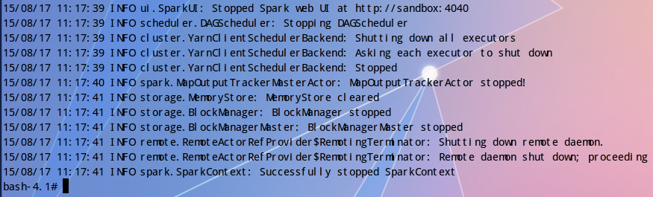
退出docker容器：exit
